

**King Fahd University of Petroleum and Minerals**

**Information and Computer Science Department**

**ICS 324**

**Term 143**

**Phase 1: Conceptual and Logical Design**

|  |  |
| --- | --- |
| Member | ID |
| Ibrahim BinAlshikh | 201139750 |
| Ibrahim Albeladi | 201224780 |
| Aqeel Alfakhr | 201236760 |

Table of Contents

1. Problem Statement 2

2. Assumptions 2

3. Database Requirements (defines the entities, attributes, relationships and constraints). 2

4. Conceptual schema (ER/EER Model) 3

5. Relational schema (all relations and constraints) 3

6. DDL statements to create database tables 4

# Problem Statement

We have to design and implement a database that can be used by academic institutions to record the grades of students in specific course. To design this, we have to consider 3 main actors: student, instructor and a course. Each of those will affect the final product.

# Assumptions

* 1. We will assume that the database will be made for KFUPM use.
  2. We will assume that the length of names will not exceed 15 characters.
  3. We will assume that the condition for most relations on delete will be ‘set null’.
  4. When a section is removed, all students will be removed from that section.
  5. Assume that each course will have at least 2 grading component.
  6. Assume that the number of grading component for all courses won’t exceed 1000.
  7. Assume that each college and department has an alphabetic unique ID that represents it.
  8. Assume that the section reference number will be formed as follows: College ID + Department ID + course number + section number + term number(e.g. ccse-ics111-1-53-1)
  9. Assume that every year the section reference number is recycled.
  10. Each section will be taught by one instructor.
  11. Assume that the sum of all points on a section can be less than 100 or more.

# Database Requirements (defines the entities, attributes, relationships and constraints).

We can summarize the database requirements as follows:

1. Students’ first and last names and majors shall be recorded and be identified with a unique student id
2. Courses’ number shall be recorded and it shall be identified with a unique course id
3. Each section must belong to a course in a specific term and shall be identified by a unique section number and taught by an instructor
4. The section is made up from several grading components where each has a maximum points and an overall weight
5. Sections must have enrolled students
6. The instructor will be able to record points for students
7. Instructors shall be able to assign letter grades and grade cutoffs for each of his section

# Conceptual schema (ER/EER Model)

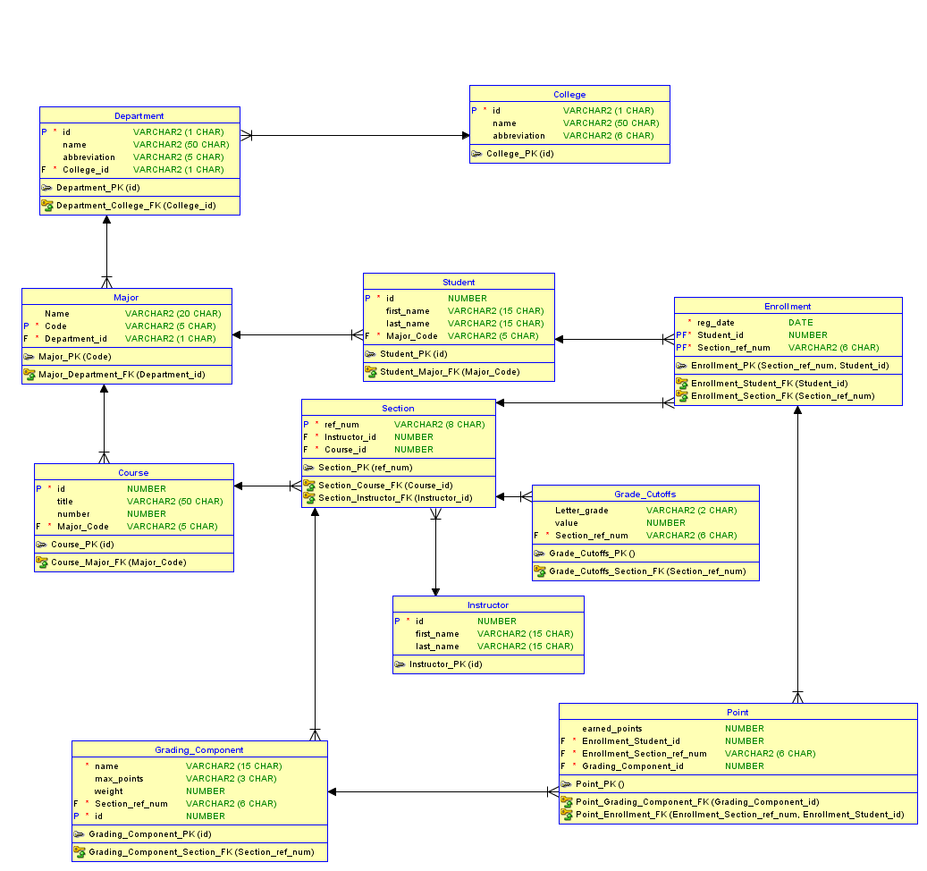

# Relational schema (all relations and constraints)

1. Every college will have many departments
2. Each student will have a major
3. Each student can register in many sections
4. One instructor can teaches many sections
5. The instructor can create grading components.
6. Each course will have many grading components.
7. Each enrollment will have many grading components.

# DDL statements to create database tables

See the file DDLStatments.sql

# Tools and languages used

We used java as our main programming language. But each member used different IDE for programming. Ibrahim BinAlshikh used NetBeans IDE, Ibrahim Albeladi used Eclipse and Aqeel used JCreator. We also use GitHub which is an application that can be used as code repo.

Also we used oracle data modeler to draw our ER/EER diagram.

# The user manual

See the file: UserManual.docx

# Conclusion

It was nice experience to build our first database application. One thing that we did not consider is the time. We tried to make our project for generic use and not for only one instructor which make it difficult for us to finish in time. Also we had difficulties working with new tools such as GitHub and Oracle Data Modeler. We west some time in learning how to use them properly. Also we had problems at the end when we tried to integrate the work since we divided the application to 3 branches and each one was working on his own branch. At the end, we managed to resolve some problems and finish the project.

# Who did what

1. Ibrahim BinAlshikh
2. ER/EER Model Initial
3. Project Report Completion and review
4. Programming: Administration part of the project (databaseapplication.admin)
5. Programming: All reusable Frameworks
6. Programming: SuperManager, ConnectionManager, LoginDialog
7. Ibrahim Albeladi
   1. Created a group in the WhatsApp
   2. ER/EER Model Final
   3. Created a repository in GitHub
   4. Revised the assumptions
   5. Brainstorm the application requirements
   6. Revised the conceptual schema
   7. Programming: Instructor Part (databaseapplication.instructor)
   8. Programming Part: CommonMethods
8. Aqeel Alfakhr
   1. Relational schema
   2. ER/EER Model Final
   3. Programming Part: Student (databaseapplication.student)